Maria Höhn PhD

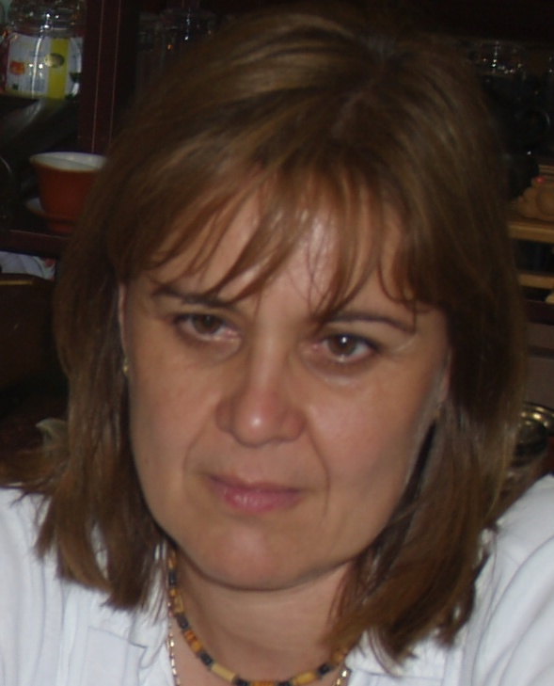

She is associate professor at Corvinus University of Budapest, Faculty of Horticultural Sciences, Department of Botany
Her main research topics include
- vegetation studies along the Carpathian basin and the Carpathians, with special account on protected plant species
- population diversity and biogeography of Swiss stone pine (Pinus cembra L.), a glacial relict species of Europe,
- genetic structure of native Pinus sylvestris L. populations inhabiting extreme habitat sites from East-Central Europe
Selected publications
- HÖHN M. (1998): A Kelemen-havasok növényzetéről. (About the vegetation of the Calimani Mountains (Eastern Carpathians) Menthor. Marosvásárhely (Targu-Mures). p. 1–114. in Hungarian language.

- MÉSZÁROS S., HÖHN M. (2002): Species diversity and advancement of Swertia (Gentianaceae) ecological and morphological correlates. Acta Bot. Hung. 44 (3-4): 317-334.

- HÖHN M., ÁBRÁN P., VENDRAMIN, G.G. (2005): Genetic analysis of Swiss stone pine populations (Pinus cembra L. subsp. cembra) from the Carpathians using chloroplast microsatellites. Acta Silv. Lign. Hung. 1: 39-43

- HÖHN M., GUGERLI, F., ABRAN P., BISZTRAY, GY, BUONAMICI, A., CSEKE K., HUFNAGEL L., QUINTELA-SABARÍS C., SEBASTIANI F., VENDRAMIN, G.G.,(2009): Variation in the chloroplast DNA of Swiss stone pine (Pinus cembra L.) reflects contrasting post-glacial history of populations from the Carpathians and the Alps. Journal of biogeography. 36. 9: 1798-1806. IF(2009) 4.087

- CSERGŐ, A.-M., SCHÖNSWETTER, P., MARA, GY., DEÁK, T., BOŞCAIU, N., HÖHN, M., (2009): Genetic structure of peripheral, island-like populations: a case study of Saponaria bellidifolia Sm. (Caryophyllaceae) from Southeastern Carpathians. Plant Syst. Evol. 278. pp.33-41. IF (2009) 1.492

- HÖHN M., HUFNAGEL L., CSEKE K., VENDRAMIN, G.G. (2010): Current range characteristics of Swiss Stone pine (Pinus cembra L. ) along the Carpathians characterized by chloroplast SSR markers. Acta Biologica Hungarica. 61(suppl): 61-68. IF (2009): 0.551

- BODOR, P.; HÖHN, M.; PEDRYC, A.; DEAK, T.; DÜCSO, I.; UZUN, I.; CSEKE, K.; BÖHM, E. I.; BISZTRAY, G. D. (2010): Conservation value of the native Hungarian wild grape (Vitis sylvestris Gmel.) evaluated by microsatellite markers. Vitis. 49 (1): 23-27. IF: 0.800

- BODOR, P. – HÖHN, M. – DEÁK, T. – BISZTRAY, GY.D. (2011): Morphological and molecular identification of invasive and autochthonous Vitis taxa along Hungary. In: Bohren, C.; Bertossa, M.; Schönenberger, N.; Rossinelli, M.; Conedera, M. (ed) 3rd International Symposium of Environmental Weeds and Invasive Plants. October 2 to 7 2011.Monte Verità, Ascona, Switzerland. Extended Abstracts: www.wsl.ch/epub/ewrs/sessions/detail_EN.

